实验4 Spring入门

一、实验目的
- 理解Spring的概念、优点和体系架构；
- 掌握Spring配置文件的创建
- 掌握Spring的两大核心容器的实例化方法
- 熟悉Spring程序的编写及setter注入方法

二、实验步骤：
【截图】代码及运行结果截图：
- pom.xml文件

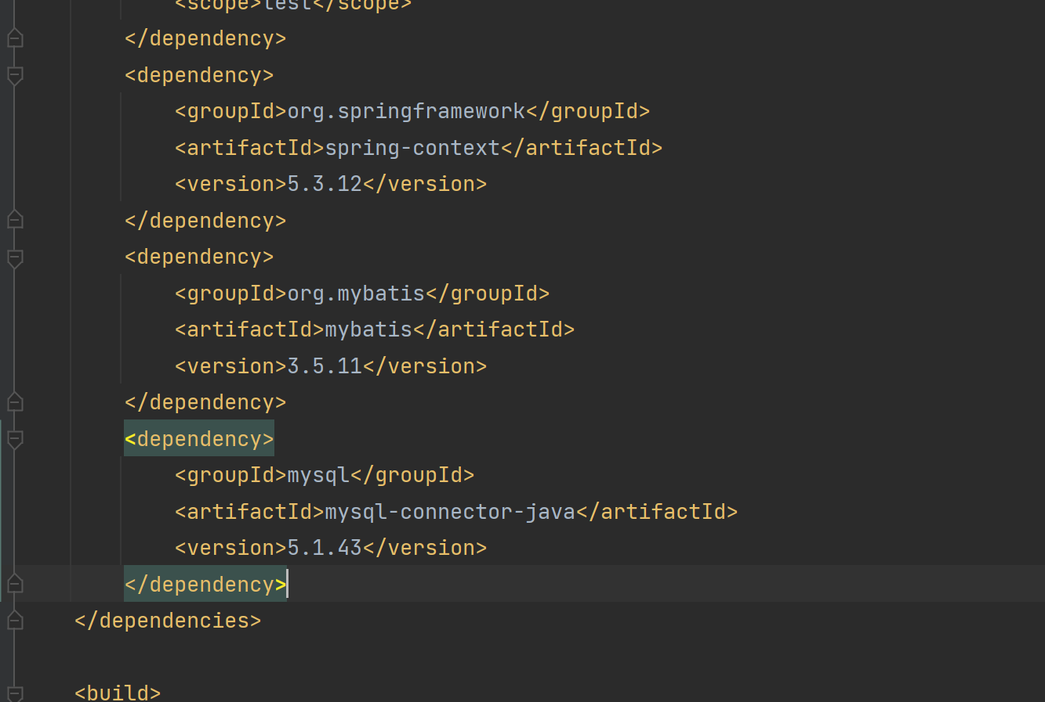

- applicationContext.xml文件

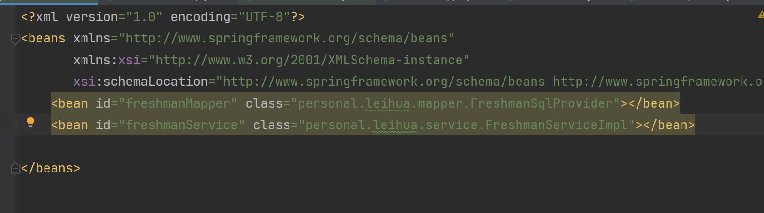

- TestSpring.java
- import org.junit.jupiter.api.Test;
import org.springframework.context.support.ClassPathXmlApplicationContext;
import personal.leihua.pojo.Freshman;
import personal.leihua.service.FreshmanServiceImpl;
import java.text.DateFormat;
import java.util.Date;
import java.util.HashMap;
import java.util.List;
/**
* @Author leiHua
* @Date 2023/2/28 12:39
*/
public class FreshManServiceTest {
@Test
public void testSelect(){
ClassPathXmlApplicationContext context = new ClassPathXmlApplicationContext("applicationContext.xml");
FreshmanServiceImpl freshmanService = context.getBean(FreshmanServiceImpl.class);
List<Freshman> allFreshman = freshmanService.findAllFreshman();
for (Freshman freshman : allFreshman) {
System.out.println(freshman);
}
}
@Test
public void testAddFreshMan(){
ClassPathXmlApplicationContext context = new ClassPathXmlApplicationContext("applicationContext.xml");
FreshmanServiceImpl freshmanService = context.getBean(FreshmanServiceImpl.class);
Freshman freshman = new Freshman();
freshman.setTicketNumber("20407063010000");
freshman.setIdCard("445222199904254019");
freshman.setName("玛卡巴卡");
freshman.setSex(0);
freshman.setAge(22);
freshman.setBirthday(new Date());
System.out.println(freshmanService.addFreshMan(freshman));
}
@Test
public void testDelete(){
ClassPathXmlApplicationContext context = new ClassPathXmlApplicationContext("applicationContext.xml");
FreshmanServiceImpl freshmanService = context.getBean(FreshmanServiceImpl.class);
HashMap<String, Object> map = new HashMap<>();
map.put("ticketNumber","18220802151131");
int i = freshmanService.deleteFreshman(map);
if (i>0){
System.out.println("删除成功");
}else{
System.out.println(i);
}
}
@Test
public void update(){
ClassPathXmlApplicationContext context = new ClassPathXmlApplicationContext("applicationContext.xml");
FreshmanServiceImpl freshmanService = context.getBean(FreshmanServiceImpl.class);
List<Freshman> allFreshman = freshmanService.findAllFreshman();
Freshman freshman = allFreshman.get(1);
System.out.println(freshman);
freshman.setAge(25);
int result = freshmanService.updateFreshman(freshman);
System.out.println(result);
}
}

- FreshmanService.java
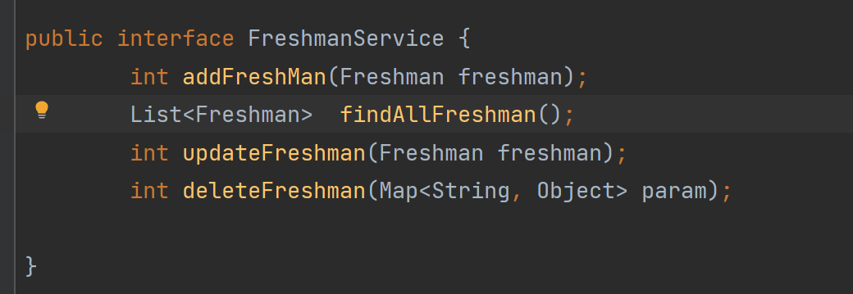

- FreshmanServiceImpl.java

package personal.leihua.service;
import org.apache.ibatis.session.SqlSession;
import personal.leihua.mapper.FreshmanMapper;
import personal.leihua.pojo.Freshman;
import personal.leihua.utils.MybatisUtils;
import java.util.List;
import java.util.Map;
/**
* @Author leiHua
* @Date 2023/2/28 12:27
*/
public class FreshmanServiceImpl implements FreshmanService{
private FreshmanMapper freshmanMapper;
public void setFreshmanMapper(){
SqlSession session = MybatisUtils.getSession();
FreshmanMapper mapper = session.getMapper(FreshmanMapper.class);
this.freshmanMapper=mapper;
}
@Override
public int addFreshMan(Freshman freshman) {
if (freshmanMapper==null){
setFreshmanMapper();
}
int result=freshmanMapper.addFreshman(freshman);
return result;
}
@Override
public List<Freshman> findAllFreshman() {
if (freshmanMapper==null){
setFreshmanMapper();
}
return freshmanMapper.findAllFreshmans();
}
@Override
public int updateFreshman(Freshman freshman) {
if (freshmanMapper==null){
setFreshmanMapper();
}
return freshmanMapper.updateFreshman(freshman);
}
@Override
public int deleteFreshman(Map<String, Object> param) {
if (freshmanMapper==null){
setFreshmanMapper();
}
return freshmanMapper.deleteFreshman(param);
}
}

- 运行截图

